C:\Users\Tavio\AppData\Local\Microsoft\Windows\Temporary Internet Files\Content.IE5\RJZUTYU3\MC900229659[1].wmf C:\Users\Tavio\AppData\Local\Microsoft\Windows\Temporary Internet Files\Content.IE5\W9VEI4HL\MC900018776[1].wmf

Grade 3 Social Studies Poster Project:

Settlement in Upper Canada

A **report** is **a** **way to present information** about a topic to an audience. A report can be presented in many ways including **posters**, and you need to focus on the information you are going to share. Remember that your poster needs to **get the audience’s attention** with **eye-catching titles and pictures**. A strong poster report also **teaches the audience** about the topic. You have experience with brochures, so just think big!

**\*Information**: You will be creating a poster to show what know about the differences and similarities of living in Upper Canada around 1800, with present-day living in our city. Your report will focus on the **2 key topics** we’ve learned about pioneer living so far:

**Pioneer Villages – Pioneer Homes**

Create a poster that shares information about:

* 2-3 similarities to how we live in our city with titles, words, and pictures;
* 2-3 differences to how we live in our city with titles, words and pictures.

You can choose to work only on pioneer villages or homes if you would like, or you can mix it up however you want. You need to have at least 2 differences and similarities presented. **Neatness**, a **main title**, and **pictures with labels** are also part of your success criteria.

Due date: **April 15, 2013**

This is the rubric that will be used to grade your poster report project.

|  |  |  |  |  |
| --- | --- | --- | --- | --- |
|  | Level 4 - A | Level 3 - B | Level 2 - C | Level 1 - D |
| **Design** | The poster is **very neat**, and **well organized** with **labels** and **pictures**. The information is easy to read and follow. | The poster is **neat**, and **organized** with **labels** and **pictures**. The information is easy to follow. | The poster is **organized** with **labels** and **pictures**. Some information is not easy to follow. | The poster is **messy**. The information is not easy to follow. |
| **Ideas** | The poster **answers all of the ideas clearly and effectively** to the audience. | The poster **answers most of the ideas clearly and effectively** to the audience. | The poster **answers some of the ideas clearly** to the audience. | The poster **answers few of the ideas. Answers are not clear** to the audience. |
| **Conventions** | **All** of the writing is done in complete sentences.  Capitalization and punctuation are correct **through** the poster. | **Most** of the writing is done in complete sentences.  **Most** of the capitalization and punctuation are correct. | **Some** of the writing is done in complete sentences.  **Some** of the capitalization and punctuation are correct. | **Most** of the writing **is not** done in complete sentences.  **Most** of the capitalization and punctuation **are not** correct. |
| **Graphics** | The graphics **go well** with the text, and there is a **good mix** of text and graphics. | The graphics go well with the text, **but there are so many that they distract** from the text. | The graphics go well with the text, **but there are too few.** | The **graphics do not go with the text** or appear to be randomly chosen. |

Adapted from: <http://www.readwritethink.org/files/resources/lesson_images/lesson961/Rubric.pdf>

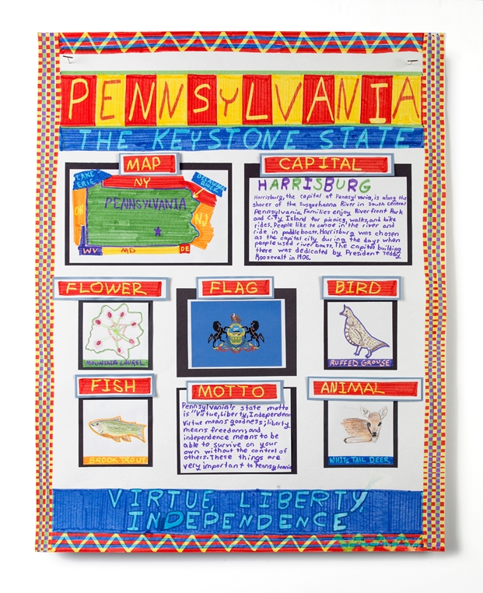

Let’s use this poster to look at the rubric.

Source: http://www.crayola.com/crafts/posters-that-pop-craft/