Mr. G and Mr. C have an equally likely chance to pull the colour they want from the bag. I know this because the probability of pulling a blue triangle is 6 out of 12, and the probability of pulling a red triangle is also 6 out of 12. Since both outcomes are equal, they are equally likely to happen.
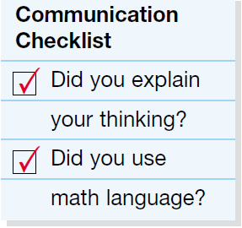
*I used information from the original question to help me communicate!

